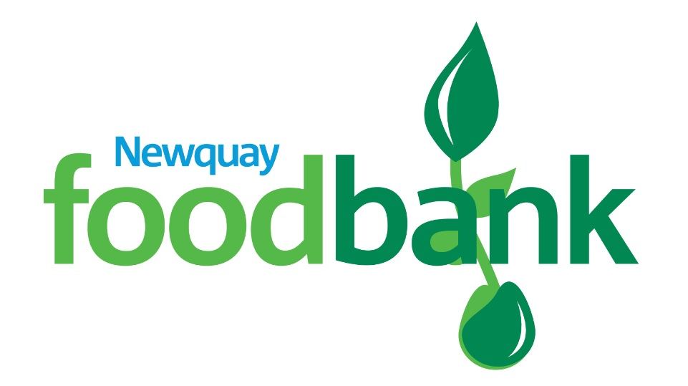

STATEMENT OF INTENT
Updated Nov 21

STATEMENT OF INTENT

- POLICY CONTROL

Version | Description | Date
2.0 | Statement of Intent | 03 Nov 21
Board Approved |  | 22 Nov 21
For Review: |  | 22 Nov 22
Chair (21/22) |  | Clare Anderson
- TAKEN FROM THE FOODBANK CONSTITUTION – 01 Jul 2020
  - The charity’s objects (‘the objects’) are the relief of financial hardship for the public benefit by distributing food to people in need of food supplies due to lack of funds leading to food poverty.
  - Additionally, signposting and working alongside referring agencies, to ensure correct support is accessed to alleviate the underlying cause of Food Poverty.
- REVIEW
  - This policy and its implementation will be reviewed at least annually or where significant financial changes occur.

