**Newquay Foodbank Volunteer Role Profile**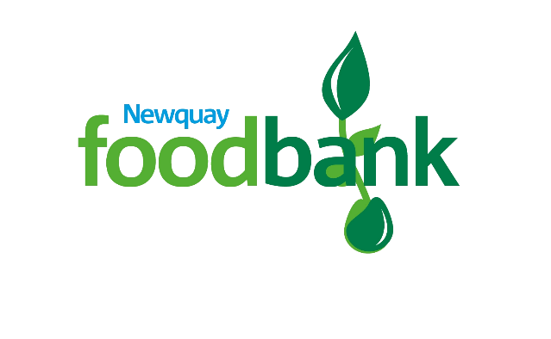

Volunteer Role: Thursday Session Volunteer

Volunteer Manager: Session Lead

Where you will be based: Variable

Time Commitment: 4-8 hours per month

**Why you should join Newquay Foodbank:**

Newquay Foodbank was founded in 2011 by the community and we work to distribute food and essential items to people in Newquay, and surrounding areas, who are unable to make ends meet. We are a volunteer led organisation and rely on the skills that people from outside our organisation can bring. We are committed to ensuring that we have a sustainable operation both financially and by volunteer support and we must ensure our profile is raised in the community. This is a vital team and by volunteering as a Session Volunteer, you will make sure that clients get the support they need both by the receipt of a Foodbank parcel and the signposting on to further support as required. We are looking for volunteers to support at our new Thursday sessions, at St Michaels.

**What you will be doing** (including but not limited to)**:**

* Supporting clients who attend foodbank sessions
* Signposting clients onto further support where required
* Sorting and weighing stock as it enters the site
* Packing parcels as directed by the session lead

**Skills required:**

* Organised and able to complete tasks accurately with good attention to detail
* Ability to listen and engage with people from a diverse range of backgrounds and experiences
* Ability to get on with others and be part of a team as well as completing tasks independently
* A willingness to learn about our organisation and our place within the Trussell Trust and align to our campaigns

**Benefits of joining Newquay Foodbank:**

* Have an enjoyable experience while volunteering for a nationally recognised organisation
* Full induction and training required to undertake your role
* Access to Tempo Time Credits, earning rewards for your volunteering
* Reimbursement of out of pocket expenses
* A Newquay Foodbank uniform
* Learning new skills and utilising your existing skills to make a difference to the community
* Meet new people and be part of a motivated team who share your passion to achieve social justice

**By volunteering with Newquay Foodbank, we will ask you to commit to:**

* Treating all members of the public with dignity and respect, whilst maintaining an organisational view
* Reading and abiding by the Newquay Foodbank’s Policies and Procedures, including agreeing to and attending any training required to undertake your role
* Meeting time and other commitments as agreed