**Newquay Foodbank Volunteer Role Profile**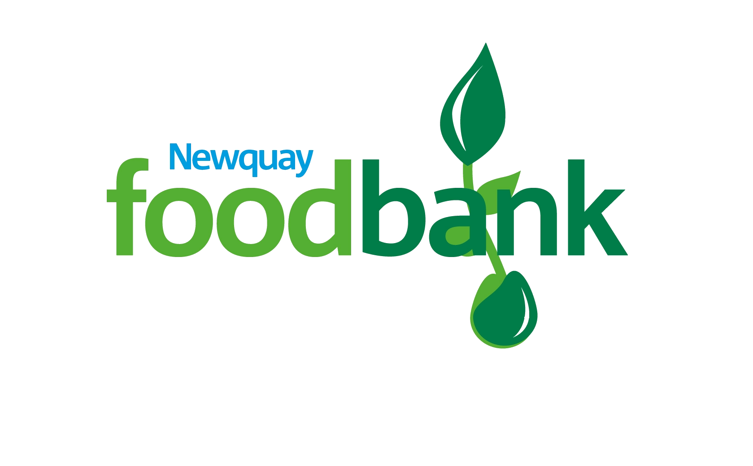

Volunteer Role: Warehouse assistant

Volunteer Manager: Volunteer Lead

Where you will be based: St Michaels Church, Newquay

Time Commitment: Mondays 8.30am -11am

**Why you should join Newquay Foodbank:**

Newquay Foodbank was founded in 2011 by the community, and we work to distribute emergency food and essential items to people in Newquay, and surrounding areas, who are facing a financial crisis. We are a volunteer led organisation and rely on the skills that people from outside our organisation can bring. We are committed to ensuring that we have a sustainable operation both financially and by volunteer support and we must ensure our profile is raised in the community. This is a newly developing team and an exciting time to join us if you like to shape the future.

By volunteering as a Warehouse stock assistant, you will be part of a team, sorting, packing and recording stock and sorting by date and type, all while making a real difference to people’s lives providing vital help and support at a time when they need it most.

**What you will be doing** (including but not limited to)**:**

* Assisting with unloading stock deliveries
* Sorting stock, stacking shelves and packing stock for delivery
* Correctly record stock weights as stock comes into the store.

**The skills you need:**

* This is a physical role and you will need to be physically fit
* Ability to accurately record stock
* Maintain a safe working environment, be vigilant to the premises and any potential hazards, ensuring you have read the risk assessment
* Organised and able to complete tasks accurately with good attention to detail
* Ability to listen and engage with people from a diverse range of backgrounds and experiences
* Ability to get on with others and be part of a team as well as completing tasks independently
* A willingness to learn about our organisation and our place within the Trussell Trust and align to our campaigns

**Benefits of joining Newquay Foodbank:**

* Have an enjoyable experience while volunteering for a nationally recognised organisation
* Full induction and training required to undertake your role
* Access to Tempo Time Credits, earning rewards for your volunteering
* Reimbursement of out of pocket expenses
* A Newquay Foodbank uniform
* Learning new skills and utilising your existing skills to make a difference to the community
* Meet new people and be part of a motivated team who share your passion to achieve social justice

**By volunteering with Newquay Foodbank, we will ask you to commit to:**

* Treating all foodbank users with dignity and respect, whilst maintaining confidentiality as set out in our Confidentiality Agreement
* Reading and abiding by the Newquay Foodbank’s Policies and Procedures, including agreeing to and attending any training required to undertake your role
* Meeting time and other commitments as agreed